**EXP NO 4: CREATE A SIMPLE CLOUD SOFTWARE APPLICATION FOR CAR**

**BOOKING RESERVATION SYSTEM USING ANY CLOUD SERVICE**

**PROVIDER TO DEMONSTRATE SAAS**.

**DATE:**

**AIM:**

To Create a simple cloud software application for Car Booking Reservation System

using any Cloud Service Provider to demonstrate SaaS.

**PROCEDURE:**

step1: Go to zoho.com.

step 2: Log into the zoho.com.

step 3: Select one application step.

step4: Enter application name as Car Booking Reservation System.

step 5: Created new application as Car Booking Reservation System.

step 6: Select one form

step 7: The software has been created.

**IMPLEMENTATION:**

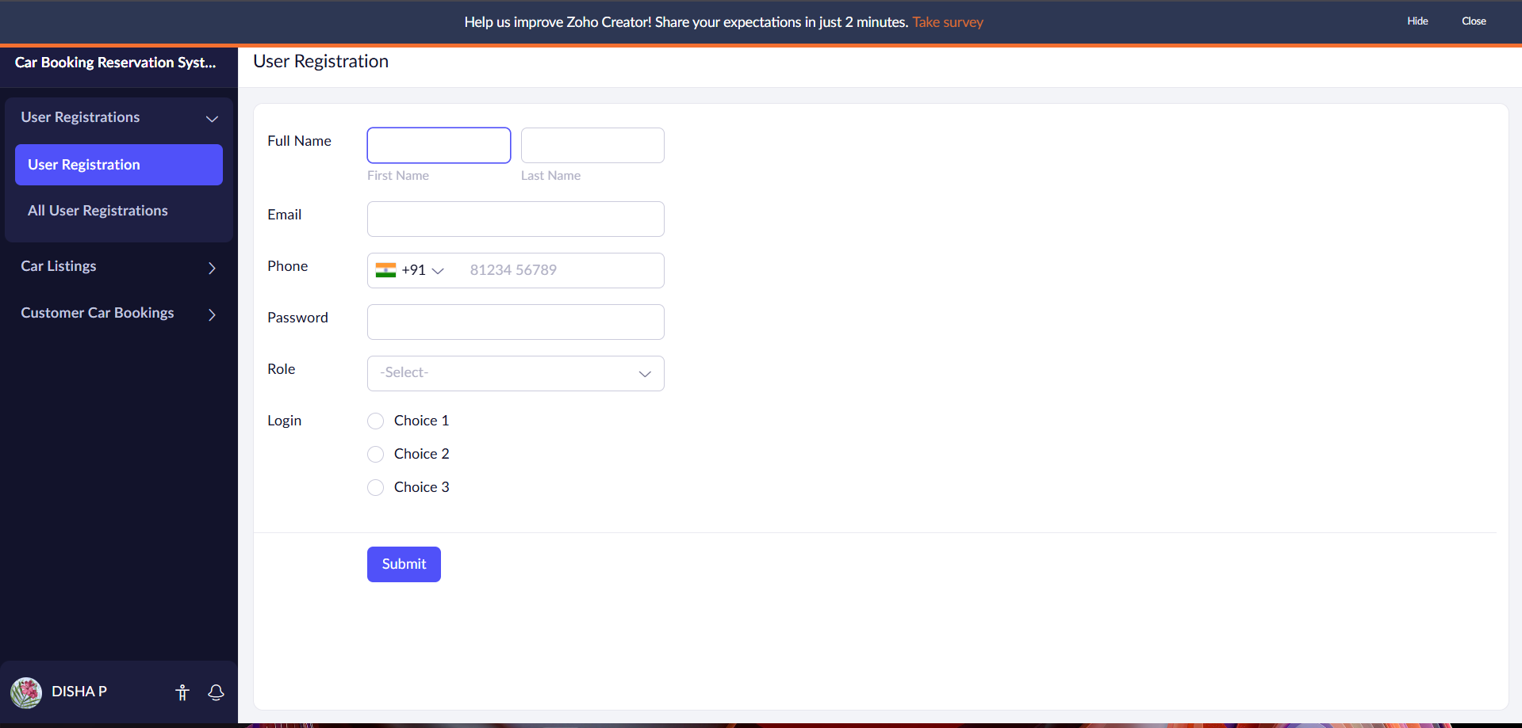

**Here form to fill details of car booking reservation system created.**

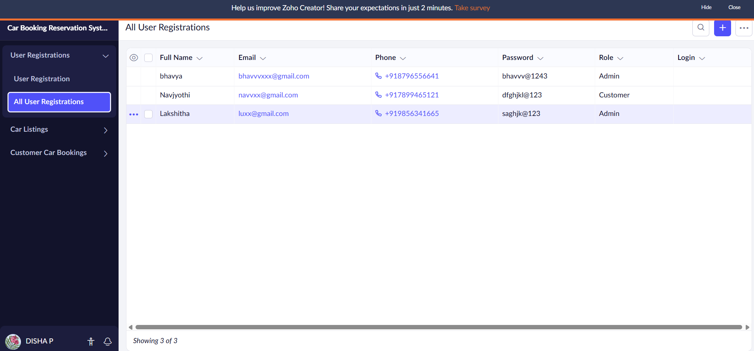

**The details have been filled.**

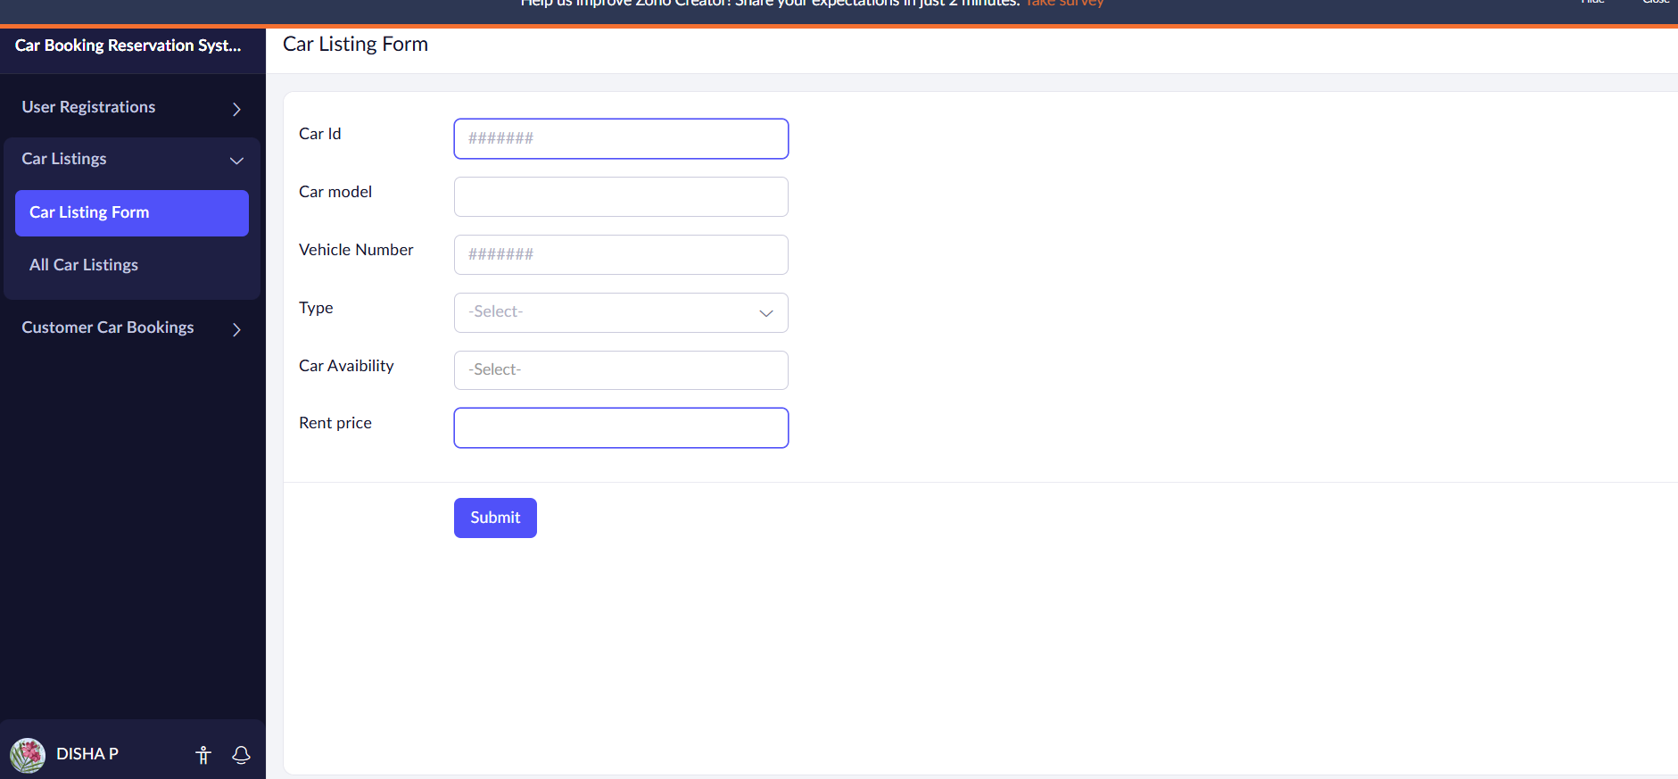

**The form has been created.**

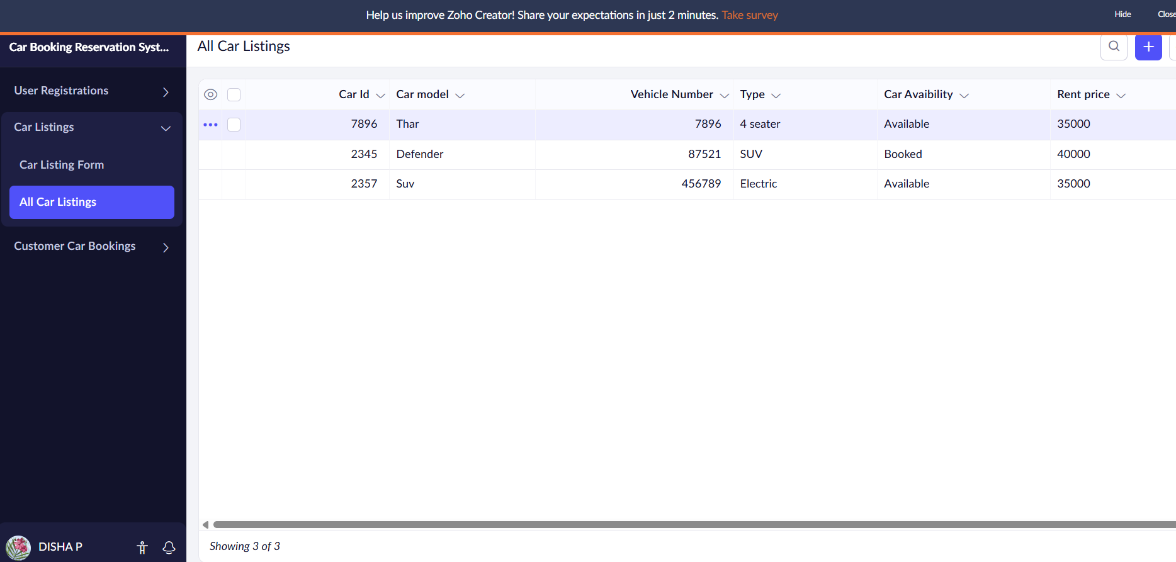

**The details have been filled**

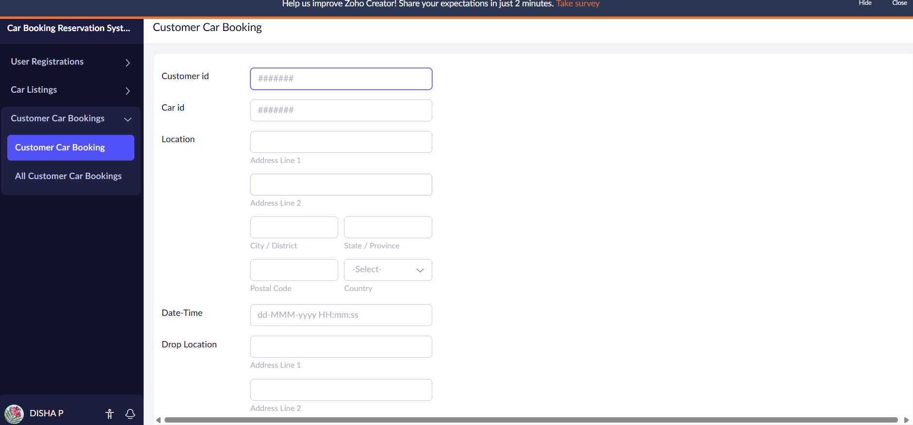

**Te form has been created to fill car booking reservation system.**

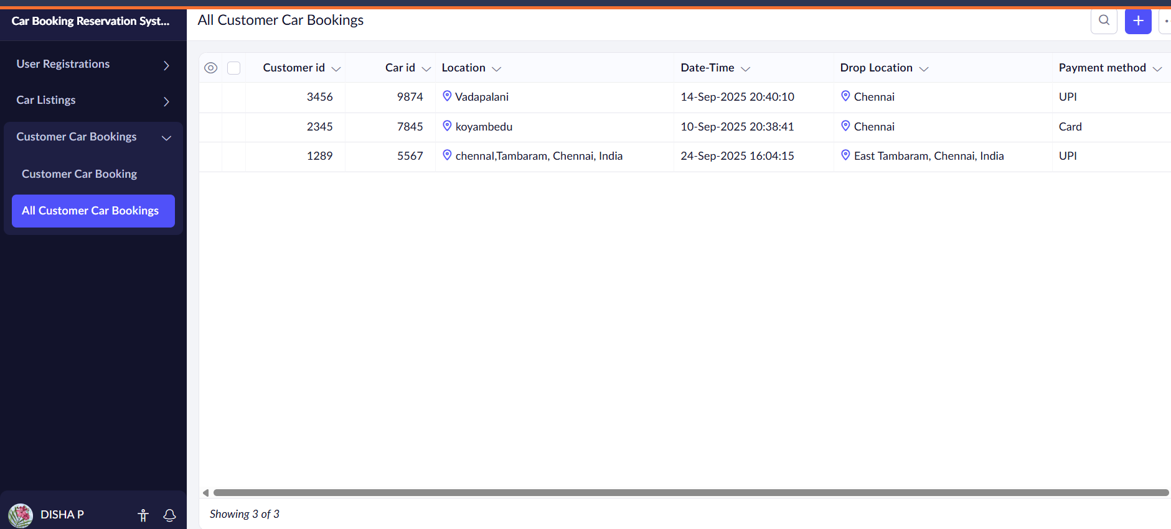

**Result:**

**Thus Car Rental booking System form has been done.**